* 1. Explain the function of this command “Router(config-if)#”

**Answer:**

This command enters you to the router interface mode. Example router(config-if)# ip address 192.168.1.5 255.255.255.0. sets the IP address and subnet mask for the specified GE interface

## EXERCISES:

* 1. For each of the following networks, discuss the consequences if the connection fails.
     1. Five devices are arranged in mesh topology?
     2. Five devices are arranged in star topology (not counting hub/switch)?
     3. Five devices are arranged in bus topology?
     4. Five devices are arranged in mesh topology?

Answer:

Data transfer /Communication between Nodes is not affected because alternative path (connection) always presented in Mash Topology.

Data transfer between Nodes is affected in the Star Topolgy , because all the node connected with centralize System(Host)

In Bus Topology All the Nodes connected with a single line so all circuit is fail if any node is drop.

Q2.) what do you mean by tree topology?

Answer:

A tree topology is a special type of structure where many connected elements are arranged like the branches of a tree.

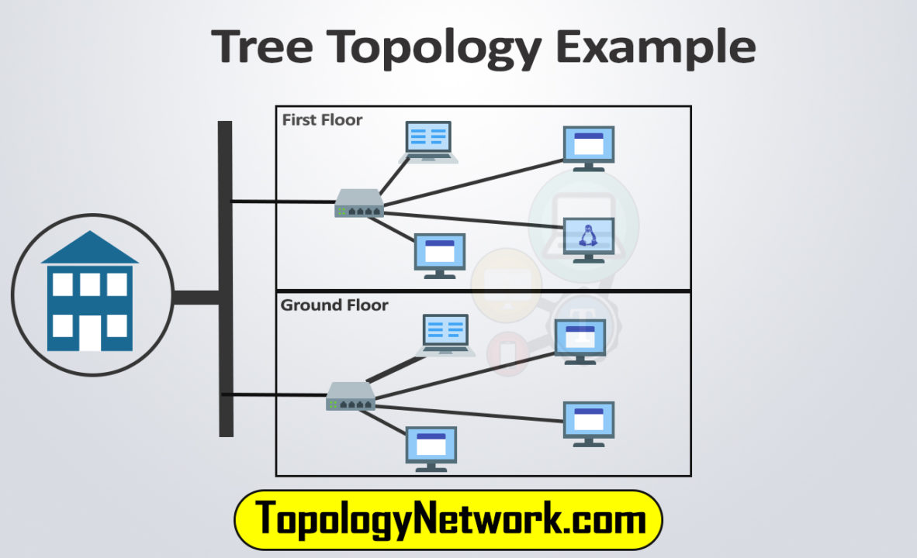

* 1. Why we use router in this network?

Answer:

Routers carry out two basic functions—they select a path between networks, and they securely transmit information packets across that path toward an intended destination.

* 1. PC1 is configured with default gateway address. PC2 is not configured with a default gateway. What would happen if PC1 pings PC2.

**Answer:**

For a PC of any network there must be a default gateway in order to send and received any data. So, in this case PC1 is configured by default gateway but PC2 is not configured by default gateway so PC1 cannot ping PC2 because there is no path available for ping address.

* 1. Define network topology?

**Answer:**

**Network topology** refers to the physical or logical layout of a network.

There are two types of network topologies: physical and logical.

1. **Physical topology** emphasizes the physical layout of the connected devices and nodes, while the
2. **logical topology** focuses on the pattern of data transfer between network nodes